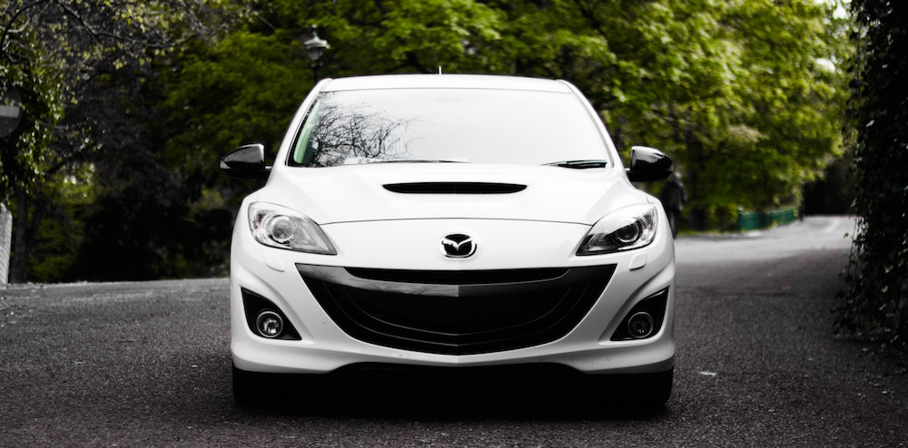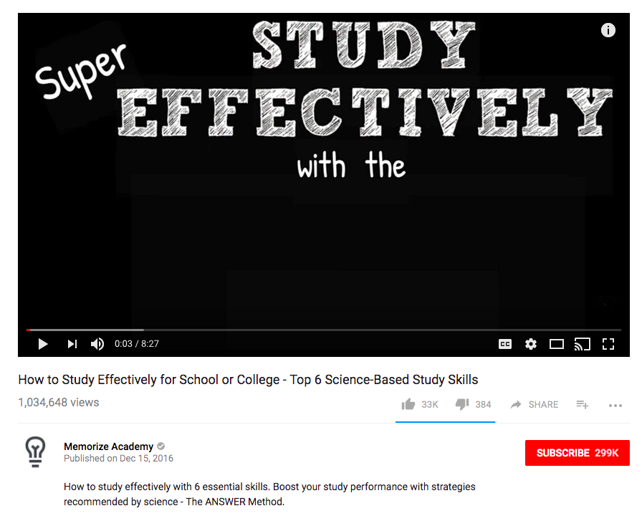

I walk you through everything you need to know when shopping for and buying a used car. With these tips, you’ll never have to worry about getting a bad deal again.

Author’s real name

**With**

**Malik Moussa**

**Buying a Used Car: The Basics**

M

malikm

Published on April 16, 2017

2,680,011 views

Buying a Used Car: The Basics

12345

0:02 / 09:14